Project Title: Diagnostic Medicare Center Manager.

|  |
| --- |
|  |

|  |  |  |
| --- | --- | --- |
| **Members** | **Name** | **Employee ID** |
| 1 | Vaishnavi Anilkumar Kulkarni | 799181 |
| 2 | Ankit Kishor Chhajed | 799234 |
| 3 | Abhishek  Sawant | 799261 |
| 4 | Amit Ashish Wani | 799272 |
| 5 | Sanhita Suresh Paluskar | 799182 |
| 6 | Mitali Shreeram Markande | 799309 |

Objectives:

Below are the objectives that shall be fulfilled post the execution of this project:

Diagnostic Medicare Center Management system will create and maintain Customer and Doctor Information.

* Create and maintain customer and doctor information.
* Search for the Medicare services.
* Customer applies for the Health Checkup.
* Customer can search for agent.
* Customer/Doctor will view the result.

# Technologies:

|  |  |
| --- | --- |
| Front End | Java (HTML5,CSS3, JavaScript, Angular) |
| Middleware | Java (Spring, Spring MVC, Hibernate MVC, Spring Boot , JWT) |
| Backend | Oracle/SQL Server |

# Hardware and Software Requirements:

|  |  |  |
| --- | --- | --- |
| Technology | Hardware | Software |
| Java 1.8 | Desktop PC with 8GB RAM | 1. Node.js 10.15.1 2. Angular 6.0 3. Visual Studio Code 1.30 4. Eclipse IDE for Java EE Developers (Oxygen) 5. Maven 3.6.0 6. Tomcat 9 7. MySQL Community Server 8.0 8. MySQL Workbench 8.0.14 9. Oracle 11g express version 10. Postman |

SYSTEM FLOW:

ADMIN:

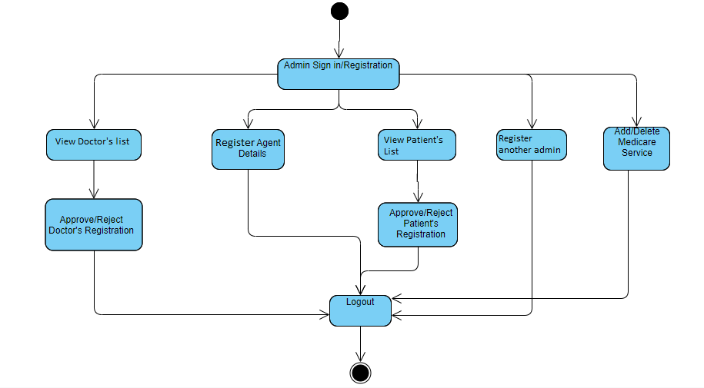

PATIENT:

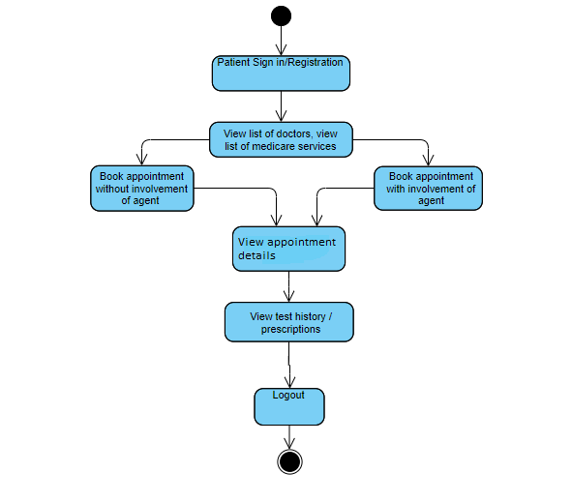

DOCTOR:



AGENT:

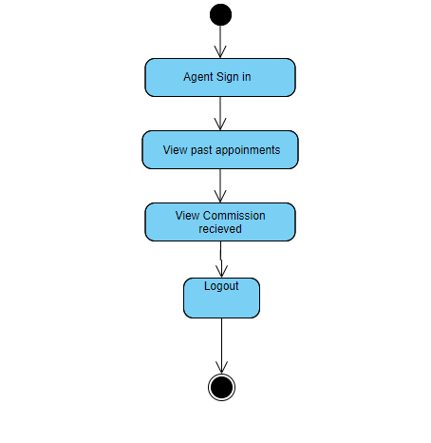

ER DIAGRAM:

Please refer the attached document in the mail for ER Diagram.

BUSINESS REQUIREMENTS:

Note - Primary focus is to complete developing the critical requirements (highlighted in Yellow) and then to proceed with the remaining requirements.

US : User Stories.

REQ: Requirements/sub-tasks.

|  |  |  |  |
| --- | --- | --- | --- |
| **User Story ID** | **User Story Description** | **Sub tasks details.** | **Dependency of User Story** |
| US_1 | The objective of this requirement is to allow the user to Register/ login as Customer / Doctor / Admin / Agent | |  |  | | --- | --- | | ID | Short Description | | Req_1 | Initial Selection:  Ability of the system to allow to Customer to choose Admin/Customer/ Doctor Login/Registration | | Req_2 | Customer Registration:  Ability of the system to procure the fundamental details of the Customer | | Req_3 | Customer Authentication:  Ability of the system to authenticate the Customer credentials of the registered Customer | | Req_4 | Doctor Registration  Ability of the system to procure the fundamental details of the Doctor | | Req_5 | Doctor Authentication:  Ability of the system to authenticate the Doctor credentials of the registered Doctor | | Req_6 | Agent Registration:  Ability of the system to procure the fundamental details of the Agent | | Req_7 | Agent Authentication:  Ability of the system to authenticate the Agent credentials of the registered Agent | | Req_8 | Admin Registration:  Ability of the system to procure the fundamental details of the Admin | | Req_9 | Admin Authentication:  Ability of the system to authenticate the credentials of the registered Admin | | No dependency |
| US_2 | The objective of this requirement is to allow doctor to update the Medicare service Details | |  |  | | --- | --- | | ID | Short Description | | Req_10 | Add / Update Medicare Service Details:  Ability of the system to allow doctor to add / update the Medicare service Details | | Has a dependency with FS_1 |
| US_3 | The objective of this requirement is to allow Admin to update Agent Details | |  |  | | --- | --- | | ID | Short Description | | Req_11 | Update Agent details:  Ability of the system to allow Admin to update Agent Details | | Has a dependency with FS_1 |
| US_4 | The objective of this requirement is to allow the customer to have the list Medicare service / Doctor / Agent details displayed. | |  |  | | --- | --- | | ID | Short Description | | Req_12 | View Medicare Service/ Doctor details :  Ability of the system to list Medicare service / Doctor details to the Customer / Agent. | | Has a dependency with FS_1, FS_2, FS_3 |
| US_5 | The objective of this requirement is to allow Customer to raise Checkup request | |  |  | | --- | --- | | ID | Short Description | | Req_13 | Book appointment :  Ability of the system to allow Customer / agent to book appointment | | Req_14 | Approval / Denial for appointment:  Ability of the system to allow Doctor / Admin to approve / deny the | | Req_15 | View Appointment status:  Ability of the system to allow Customer / agent to view appointment status. | | Req_16 | Send remainders:  Ability of the system to send remainder messages to Doctor / Patient upon the Appointment approval. | | Has a dependency with FS_1, FS_2, FS_3, FS_4 |
| US_6 | The objective of this requirement is to allow the Doctor to update the Test result and treatment history | |  |  | | --- | --- | | ID | Short Description | | Req_17 | Add / Update Medicare Service Details:  Ability of the system to allow doctor to add / update the Medicare service Details | | Req_19 | Update Treatment / prescription details:  Ability of the system to allow Doctor to update Treatment / prescription details | | Req_20 | Maintain treatment history:  Ability of the system to allow doctor to maintain the treatment history of the patient | | Has a dependency with FS_1, FS_5 |
| US_7 | The objective of this requirement is to allow customer / doctor to view the updated test result, treatment history | |  |  | | --- | --- | | ID | Short Description | | Req_18 | View Test Result :  Ability of the system to allow customer / doctor to view the updated test result. | | Req_21 | View treatment history:  Ability of the system to allow patient to view the treatment history | | Has a dependency with FS_1, FS_5 |
| US_8 | The objective of this requirement is to allow customer to chat with doctor | |  |  | | --- | --- | | ID | Short Description | | Req_22 | Chat with Doctors:  Ability of the system to allow Patients to chat with Doctors | | Has a dependency with FS_1, FS_5 |
| US_9 | The objective of this requirement is to allow customer to get technical help | |  |  | | --- | --- | | ID | Short Description | | Req_23 | Help:  Page to assist the Customers to report technical issues | | Has a dependency with FS_1 |
| US_10 | The objective of this requirement is to allow customer to get other validations like forget user id, password | |  |  | | --- | --- | | ID | Short Description | | Req_24 | Other validations:  Ability of the system to allow add on validations like Forget Customer ID, Forget Password | | Has a dependency with FS_1 |
| US_11 | The objective of this requirement is to allow customer to provide reviews, admin to update review questions, system to trigger for review | |  |  | | --- | --- | | ID | Short Description | | Req_25 | Reviews :  Ability of the system to allow the Customer to provide feedback / reviews for Doctor / Service | | Req_26 | Review Questionnaire:  Ability of the system to allow admin to create review questionnaire for the Doctor / Service | | Req_27 | Trigger Review:  For an appointment, once the treatment / follow up is completed, on the next log trigger message to the Customer for Review. | | Has a dependency with FS_1, FS_5 |
| US_12 | The objective of this requirement is to allow system to calculate Agent commission, agent to view commission and admin to update commission | |  |  | | --- | --- | | ID | Short Description | | Req_28 | Agent commission:  Ability of the system to calculate agent commission based on the service | | Req_29 | Agent commission:  Ability of the system to allow Agent to view Commission details. | | Req_30 | Update Commission details :  Ability of the system to allow admin to update commission details for the services. | | Has a dependency with FS_1, FS_5 |
| US_13 | The objective of this requirement is to allow admin to pull report | |  |  | | --- | --- | | ID | Short Description | | Req_31 | Admin reporting :  Ability of the system to pull report for any service, agent, doctor. | | Has a dependency with FS_1, FS_5 |
| US_14 | The objective of this requirement is to allow the user to Log off upon completion of the required activity | |  |  | | --- | --- | | ID | Short Description | | Req_32 | Customer / Admin logoff :  Ability of the system to enable Customer / Admin to logoff | | Has a dependency with FS_1 |

## **DATABASE DESIGN:**

## Table 1

## **Patient / User**

|  |  |  |  |  |
| --- | --- | --- | --- | --- |
| **Field Name** | **Field Type** | **Data Type** | **Mandatory** | **Possible Values** |
| Patient / User ID | Text(10) | Alphabetic | Yes | System Generated |
| First Name | Text(50) | Alphabetic | Yes |  |
| Last Name | Text(50) | Alphabetic | Yes |  |
| Age | Numeric(2) | Numeric | Yes |  |
| Gender | Drop Down | NA |  | Male, Female |
| DoB | Text(10) | Alphanumeric | No |  |
| Contact Number | Text(10) | Numeric | Yes |  |
| Alt Contact Number | Text(10) | Numeric | No |  |
| Email ID | Text(50) | Alphanumeric | Yes |  |
| Password | Text(15) | Alphanumeric | Yes |  |
| Address Line 1 | Text(100) | Alphanumeric | Yes |  |
| Address Line 2 | Text(100) | Alphabetic | No |  |
| City | Text(50) | Alphabetic | Yes |  |
| State | Text(50) | Alphabetic | Yes |  |
| Zip Code | Text(10) | Numeric | Yes |  |

## Table 2

###### Doctor

|  |  |  |  |  |
| --- | --- | --- | --- | --- |
| **Field Name** | **Field Type** | **Data Type** | **Mandatory** | **Possible Values** |
| Doctor ID | Text(10) | Alphabetic | Yes | System Generated |
| First Name | Text(50) | Alphabetic | Yes |  |
| Last Name | Text(50) | Alphabetic | Yes |  |
| Age | Numeric(2) | Numeric | Yes |  |
| Gender | Drop Down | NA |  | Male, Female |
| DoB | Text(10) | Alphanumeric | No |  |
| Contact Number | Text(10) | Numeric | Yes |  |
| Alt Contact Number | Text(10) | Numeric | No |  |
| Email ID | Text(50) | Alphanumeric | Yes |  |
| Password | Text(15) | Alphanumeric | Yes |  |
| Address Line 1 | Text(100) | Alphanumeric | Yes |  |
| Address Line 2 | Text(100) | Alphabetic | No |  |
| City | Text(50) | Alphabetic | Yes |  |
| State | Text(50) | Alphabetic | Yes |  |
| Zip Code | Text(10) | Numeric | Yes |  |
| Degree | Text(50) | Alphabetic | Yes |  |
| Specialty | Text(50) | Alphabetic | Yes |  |
| Work hours | Drop down | NA | Yes |  |
| Hospital/Clinic Name | Text(100) | Alphanumeric | Yes |  |
| Medicare Service ID | Numeric(10) | Numeric | Yes | System Generated |

## Table 3

###### Admin

|  |  |  |  |  |
| --- | --- | --- | --- | --- |
| **Field Name** | **Field Type** | **Data Type** | **Mandatory** | **Possible Values** |
| Admin ID | Text(10) | Alphabetic | Yes | System Generated |
| First Name | Text(50) | Alphabetic | Yes |  |
| Last Name | Text(50) | Alphabetic | Yes |  |
| Age | Numeric(2) | Numeric | Yes |  |
| Gender | Drop Down | NA |  | Male, Female |
| DoB | Text(10) | Alphanumeric | Yes |  |
| Contact Number | Text(10) | Numeric | Yes |  |
| Alt Contact Number | Text(10) | Numeric | No |  |
| Email ID | Text(50) | Alphanumeric | Yes |  |
| Password | Text(15) | Alphanumeric | Yes |  |

## Table 4

###### Medicare services

|  |  |  |  |  |
| --- | --- | --- | --- | --- |
| **Field Name** | **Field Type** | **Data Type** | **Mandatory** | **Possible Values** |
| Medicare Service ID | Numeric(10) | Numeric | Yes | System Generated |
| Medicare Service | Text 50 | Alphabetic | Yes |  |
| Service Description | Text(200) | Alphabetic | Yes |  |
| Amount | Numeric(10) | Numeric | Yes |  |

## Table 5

###### Agent

|  |  |  |  |  |
| --- | --- | --- | --- | --- |
| **Field Name** | **Field Type** | **Data Type** | **Mandatory** | **Possible Values** |
| Agent ID | Text(10) | Alphabetic | Yes | System Generated |
| First Name | Text(50) | Alphabetic | Yes |  |
| Last Name | Text(50) | Alphabetic | Yes |  |
| Age | Numeric(2) | Numeric | Yes |  |
| Gender | Drop Down | NA |  | Male, Female |
| DoB | Text(10) | Alphanumeric | No |  |
| Contact Number | Text(10) | Numeric | Yes |  |
| Alt Contact Number | Text(10) | Numeric | No |  |
| Email ID | Text(50) | Alphanumeric | Yes |  |
| Password | Text(15) | Alphanumeric | Yes |  |
| Address Line 1 | Text(100) | Alphanumeric | Yes |  |
| Address Line 1 | Text(100) | Alphabetic | Yes |  |
| City | Text(50) | Alphabetic | Yes |  |
| State | Text(50) | Alphabetic | Yes |  |
| Zip Code | Text(10) | Numeric | Yes |  |

## Table 6

###### Medical Test History

|  |  |  |  |  |
| --- | --- | --- | --- | --- |
| **Field Name** | **Field Type** | **Data Type** | **Mandatory** | **Possible Values** |
| Report ID | Numeric(10) | Numeric | Yes | System Generated |
| Customer ID | Text(10) | Alphabetic | Yes | System Generated |
| Doctor ID | Text(10) | Alphabetic | Yes | System Generated |
| Medicare Service ID | Numeric(10) | Numeric | Yes | System Generated |
| Agent ID | Text(10) | Alphabetic | Yes | System Generated |
| Service date | Text(10) | Alphanumeric | Yes |  |
| Test Result date | Text(10) | Alphanumeric | Yes |  |
| Diag 1 – Actual Value | Numeric(10) | Numeric | Yes |  |
| Diag 1 – Normal Range | Numeric(10) | Numeric | Yes |  |
| Diag 2 – Actual Value | Numeric(10) | Numeric | No |  |
| Diag 2 – Normal Range | Numeric(10) | Numeric | No |  |
| Diag 3 – Actual Value | Numeric(10) | Numeric | No |  |
| Diag 3 – Normal Range | Numeric(10) | Numeric | No |  |
| Diag 4 – Actual Value | Numeric(10) | Numeric | No |  |
| Diag 4 – Normal Range | Numeric(10) | Numeric | No |  |
| Diag 5 – Actual Value | Numeric(10) | Numeric | No |  |
| Diag 5 – Normal Range | Numeric(10) | Numeric | No |  |
| Diag 6 – Actual Value | Numeric(10) | Numeric | No |  |
| Diag 6 – Normal Range | Numeric(10) | Numeric | No |  |
| Doctors Comments | Text(300) | Alphabetic | Yes |  |
| Other info | Text(300) | Alphabetic | No |  |

## Table 7

###### Feedback

|  |  |  |  |  |
| --- | --- | --- | --- | --- |
| **Field Name** | **Field Type** | **Data Type** | **Mandatory** | **Possible Values** |
| Assessment id | number | numeric | Yes |  |
| Question 1 | Text(200) | Alphabetic | Yes |  |
| Question 2 | Text(200) | Alphabetic | Yes |  |
| Question 3 | Text(200) | Alphabetic | Yes |  |
| Question 4 | Text(200) | Alphabetic | Yes |  |
| Question 5 | Text(200) | Alphabetic | Yes |  |
| Question 6 | Text(200) | Alphabetic | Yes |  |
| Question 7 | Text(200) | Alphabetic | Yes |  |
| Question 8 | Text(200) | Alphabetic | Yes |  |
| Question 9 | Text(200) | Alphabetic | Yes |  |
| Question 10 | Text(200) | Alphabetic | Yes |  |

## Table 8

###### User Feedback

|  |  |  |  |  |
| --- | --- | --- | --- | --- |
| **Field Name** | **Field Type** | **Data Type** | **Mandatory** | **Possible Values** |
| User ID | Text(10) | Alphanumeric | Yes |  |
| Assessment id | number | numeric | Yes |  |
| Rating Que 1 | Text(200) | Alphabetic | Yes |  |
| Rating Que 2 | Text(200) | Alphabetic | Yes |  |
| Rating Que 3 | Text(200) | Alphabetic | Yes |  |
| Rating Que 4 | Text(200) | Alphabetic | Yes |  |
| Rating Que 5 | Text(200) | Alphabetic | Yes |  |
| Rating Que 6 | Text(200) | Alphabetic | Yes |  |
| Rating Que 7 | Text(200) | Alphabetic | Yes |  |
| Rating Que 8 | Text(200) | Alphabetic | Yes |  |
| Rating Que 9 | Text(200) | Alphabetic | Yes |  |
| Rating Que 10 | Text(200) | Alphabetic | Yes |  |
| Assessment date | Date | Date | Yes |  |